**IMPEDANCE DETECTOR**

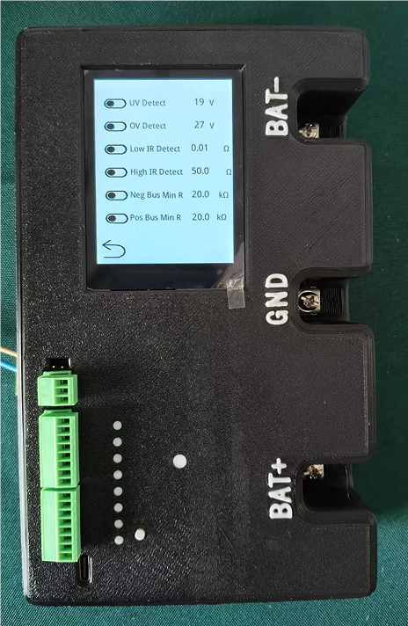

**ShiJiaZhuang HuaHeng Electronics Tech Co.,Ltd**

**------------------------------------------------------------------------------**

**1.INTRODUCTION**

MODEL ： ID-1000 high accuracy impedance detector

**1.1 brief introduction**

ID-1000 is a high precise testing device specially designed for the energy storage industry, with a number of advanced test functions, suitable for automated monitoring, power energy other fields.

**1.2main technical Parameter**

**Detecting range:**

**Battery voltage： 310.00 - 12.00 ±0.02 VDC**

**-------------------------------------------------------------------**

**Battery impedance： 0.01 - 99.99 ±0.05 ohm**

**-------------------------------------------------------------------**

**Bus to earth resistance： 100.00 - 0.01 ±0.01 kohm**

**-------------------------------------------------------------------**

**Accuracy level： 2.5class**

**----------------------------------------**---------------------------

The equipment develop by HuaHeng Electronics with passive busbar to ground resistance monitoring technology, which realizes real-time acquisition and processing of busbar to ground data, significantly improving testing efficiency and accuracy. Compared with similar products on the market, it has obvious advantages in reliability and data accuracy.

1.3products design and application

With modular design for easy maintenance and upgrade. Built-in intelligent diagnostic system, which can automatically calibrate and monitor the equipment status in real time. It can stably both in the laboratory and industrial site.

1.4 high reliability

After multiple rounds of strict testing, the detector has excellent anti-interference capability and long-term stable performance.

2.2 dimension 183*134*60mm

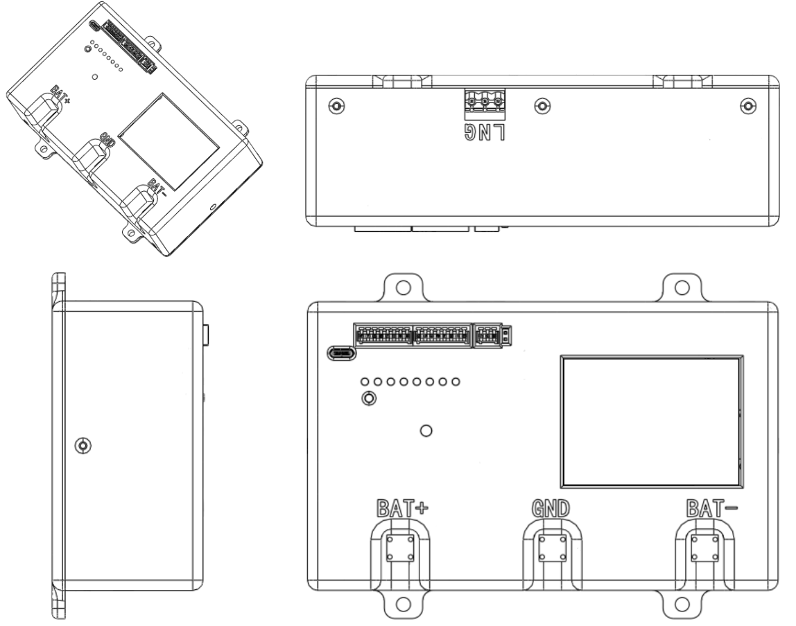

drawing 1

183*134*60mm

**2.3 Preparation before use**

① Plug in the power cord from the side interface and turn on the power.

② Turn on the device, click screen or wait 2s to enter the system.

③ Check whether the device screen operates normally and whether the system parameters can be successfully written.

④ Use a DC 4V power supply, connect the positive pole to BAT , the negative pole to BAT-, and observe whether the reading ism normal.

2.4 **plate introduction**

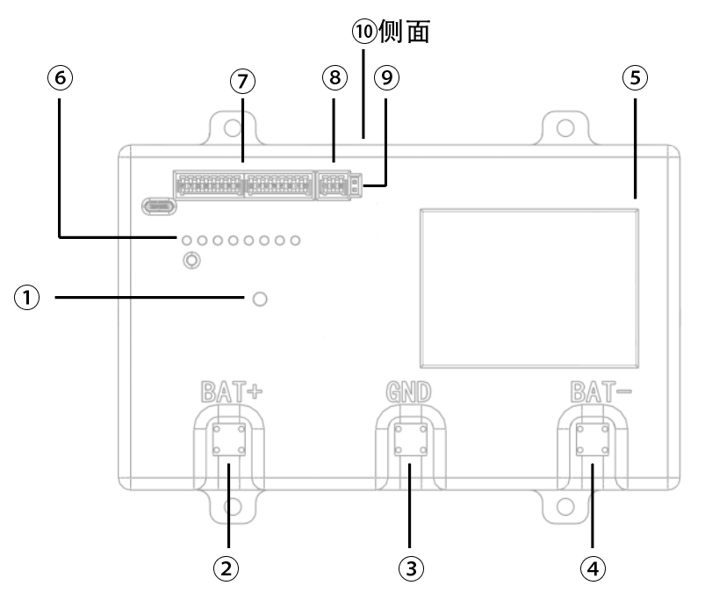

|  |  |  |  |
| --- | --- | --- | --- |
| No. | instruction | Series No. | remarks |
| 1 | Working status light | 6 | Alarm light |
| 2 | Positve bus terminal | 7 | Alarm output optocoupler. |
| 3 | Earth wiring terminal | 8 | RS485 Communication port |
| 4 | Negative bus wiring terminal | 9 | RS485 terminal resistance |
| 5 | Touch screen | 10 | Power port |

2.4.1 working status indication light

The working status indicator light can intuitively reflect whether the device is running normally through the changes of color and flashing, and prompt the user to perform fault in case of any abnormality, while also showcasing the different working modes of the device, such as standby, startup, operation, or shutdown.

**Blue light flashing quickly** Device is starting up

**Blue light flashing slowly** - Device detection program has been paused

**Green light flashing slowly** - Device monitoring program is running normally

**Orange light flashing slowly** - Device has errors but not output

**Red light flashing slowly** - Device monitoring errors and has been output

**Yellow light flashing slowly** - Device status is abnormal

2.4.2

Alarm indicator light The alarm indicator light equipped by this system is divided into 1 to 8, arranged in order from top to bottom. Each indicator to a specific alarm information, which can be intuitively viewed and modified through the touch screen, and can also be managed and configured remotely using the RS485 Modbus RT protocol.

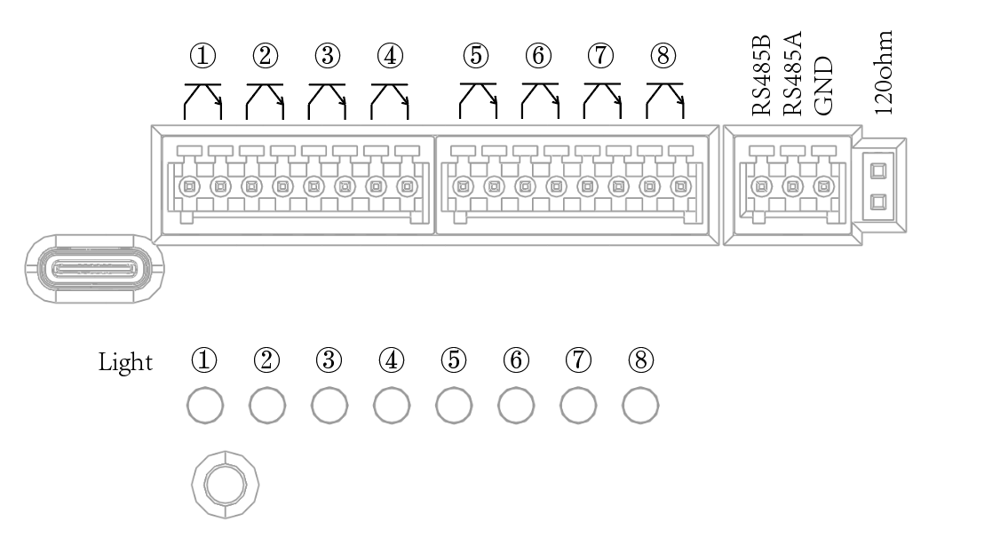

drawing 2 port and indicating light

2.4.3 **Alarm output optocoupler** The system is also equipped with eight output optocouplers (Model PC17/Interface KF128-2.54-8P), with the current flowing from top to bottom for each optocoupler interface, and the method of the output optocouplers is similar to that of the alarm indicator lights. The output status of each optocoupler can be viewed and modified via the touch, and it also supports remote configuration and management using the RS485 Modbus RTU protocol, thus achieving more flexible and efficient system control.

2.4.4  **RS485 communication interface** and terminal resistor The RS485 interface is defined from top to bottom as RS485B/RS485A/ND, and the interface itself is self-isolated, using the ModbusRTU communication protocol. If the terminal 120Ω resistor is needed, connect with a jumper cap to the pin header.

2.4.5 Power interface The power supply is universal for AC and DC. If using AC source input, interface definition from top to bottom is ground, neutral, live, and the power supply is 85-305VAC 47-63Hz. using DC source input, the interface definition from top to bottom is ground, negative, positive, and the power supply is 100-430 VDC

2.4.6 Screen The screen mainly has four interfaces: the main interface, the history interface, the alarm interface, and the interface.

2.4.6.1 **Main Interface** The main interface mainly displays the current parameters: battery voltage and battery internal resistance. These data will be updated and displayed real-time with the running of the device monitoring program. At the same time, if the data exceeds the set threshold, the alarm indicator light control will flash to prompt. .

2.4.6.2 **History Interface** The history interface is mainly responsible for displaying the historical changes in battery voltage and battery internal resistance monitored by the device. The displayed values are1 times the battery voltage and 2.5 times the battery internal resistance. Data is sampled once every 10 minutes, and up to 1152 sampling points be recorded, approximately 192 hours. The recorded data is not stored and is lost when the power is off. The history interface is entered by clicking the middle part the displayed battery voltage and battery internal resistance on the main interface.

2.4.6.3 **Alarm Interface** The alarm interface mainly displays the current alarms. Whenever monitoring exceeds the set threshold, the alarm item will be displayed in the alarm interface list. When the alarm is lifted, the data in the list is deleted.

2.4.6.4 **Setting Interface** The setting interface has four options: parameter setting, alarm setting, output setting, and screen setting.

-----------------------------------------------------------

**Parameter Settings:**

**①Detection Switch:** When this switch is enabled, the device will start real-time detection of the battery' related data; if it is turned off, monitoring is paused to save system resources to meet actual needs.

**②Modbus Switch:** When enabled, the RS485 interface be activated, allowing the device to support communication using the Modbus RTU protocol, facilitating data interconnection and sharing with other devices.

**③Local Address:** Used to set device's address in the Modbus network, with an effective address range of 1 to 255, ensuring unique identification for each device within the network. **④ the working voltage** of the battery according to the actual application scenario. The supported voltage levels include: 24V, 30V, 32V, 48, 50V, 60V, 110V, 125V, and 220V, meeting different battery configuration needs.

**⑤Internal Resistance Test Interval:** Set the time interval for testing the battery's voltage and internal resistance, with a range of 5 seconds to 600 seconds, users to flexibly adjust the test frequency according to battery performance and monitoring requirements.

**⑥Number of Data Averages:** Control the data collection process, where after every preset number times, all collected data is averaged to generate a smooth and more representative numerical result. By averaging multiple consecutive data points, the impact of single data fluctuations or random errors is effectively, improving the stability and accuracy of the overall data.

.-----------------------------------------------------------

**Alarm Settings:**

Divided into alarm item switch and parameter setting If the alarm item switch is turned on, the system will respond this alarm, otherwise it will not detect this item.

**①Under voltage detection:** When the battery voltage is lower than the set under voltage threshold, the system will trigger an alarm The parameter setting value is 101%-140% of the battery voltage grade.

**②Over voltage detection:** When the battery voltage is higher than the set over threshold, the system will trigger an alarm. The parameter setting value is 60%-99% of the battery voltage grade.

**③Battery internal resistance is too low** When the battery internal resistance is detected to be lower than the set value, the system will trigger an alarm. The parameter setting value is 0-100Ω (below set value of battery internal resistance being too high).

**④Battery internal resistance is too high:** When the battery internal resistance exceeds the set upper limit value, the system will an alarm. The parameter setting value is 0-100Ω (above the set value of battery internal resistance being too low).

**⑤Positive busbar to resistance is too low:** When the positive busbar to ground resistance is lower than the preset value, the system will trigger an alarm. The parameter setting value is 1-9kΩ.

**⑥Negative busbar to ground resistance is too low**: When the negative busbar to ground resistance is lower than the preset value, the system will an alarm. The numerical setting value is 1-99kΩ.

-----------------------------------------------------------

**Output settings:**

On the left are the indicator light output settings, from top to bottom, indicator light 1-8;

on the right are the optoupler outputs, from top to bottom, optocoupler outputs 1-8. By clicking to select the error output type: none, battery under voltage, battery voltage, battery internal resistance too low, battery internal resistance too high, positive bus ground fault, negative bus ground fault.

When the corresponding alarm is triggered, the corresponding indicator lightoptocoupler is turned on.

-----------------------------------------------------------

**3 main Parameter**

|  |  |
| --- | --- |
| **Power** | |
| DC INPUT | 85-305 VAC 47-63Hz |
| AC INPUT | 100-430 VDC |
| POWER | 2.34 W |

|  |  |  |
| --- | --- | --- |
| **INPUT (DC)** | | |
| BATTERY V RATING SET | MIN | MAX |
| RANGE | 12V | 310V |
| 24V | 14V | 34V |
| 30V | 18V | 42V |
| 32V | 19V | 45V |
| 48V | 28V | 68V |
| 50V | 30V | 70V |
| 60V | 36V | 84V |
| 110V | 66V | 154V |
| 125V | 75V | 175V |
| 220V | 132V | 308V |

|  |  |
| --- | --- |
| **MEASURE BATTERY IMPEDANCE** | |
| MAX | MIN |
| 99.99Ω | 0.01Ω |

|  |  |
| --- | --- |
| **POSITIVE AND NEGATICE BUS TO EARTH RESISTANCE** | |
| MAX | MIN |
| 100.00kΩ | 0.01kΩ |

|  |  |
| --- | --- |
| **AMBIENT REQUIREMENTS** | |
| TEMPERATURE | WORK：-20℃ - +40℃ STORAGE：-20℃ - + 50℃ |
| HUMIDITY RANGE | WORK：85%RH， 40℃ STORAGE：85%RH， 65℃ |
| ALTITUDE | WORK：≤3000m STORAGE：≤5000m |

|  |  |
| --- | --- |
| **MECHANIC FEATURE** | |
| SHELL MATERIAL | Flame retardant heat resistant plastic(UL94V-0) |
| DIMENSION | 37.50 x 21.00 x 19.00mm |
| WEIGHT | 22g (Typ.) |
| COOLING METHOD | NATURAL AIR COOLING |